**Web Programming Language - Final Project Report**

* **Project Title**

Online Restaurant Orders

* **Name for the Website**

DALAO HOTPOT (<http://eys.red>)

* **Project Description**
  + **Abstract** - Dalao Hotpot is a website that implements functions of making orders online. Users are allowed to search their favorite dishes in our website with various filters in the left side. Once a user has decided what dishes to buy, they could click on the dishes they want in order to add them into the cart. The user would see the dishes they selected and the price details for their order, then they could proceed to check-out. As the user successfully makes an order (by clicking check-out button), the order would be recorded into the order history window at the same time. The user is allowed to check all orders he/she has made by clicking “My orders” button in the drop-down list on the navigation bar. Note that Dalao Hotpot also enables admin mode that certain users are authorized to edit dishes (add / delete / update) listed in the main page.
  + **Homepage** - Homepage contains five sections. Header fixed on top, search bar, menu and cart as a row as main section, footer on bottom. We mainly use Bootstrap to arrange the layout. What is cool is both search bar and cart can be hidden, and three sections will automatically adjust to their layout respectively.

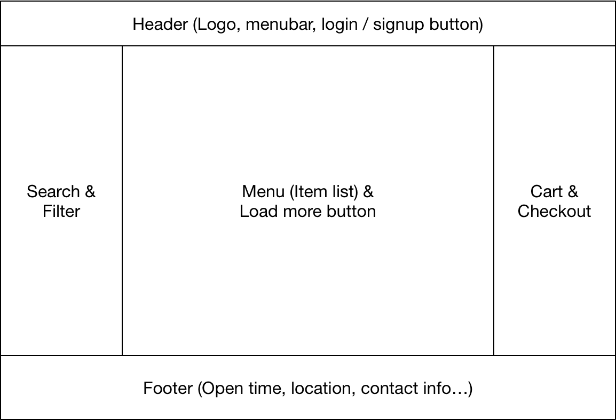

* + **Login & Signup** - Users visit our website are able to sign up as a user. Login and Sign up buttons are easily accessible on the right side of the header. Users are required to provide username(unique), mobile(unique), email(unique), password and name. All fields are validated on both front-end and server-side to protect user privacy and the server. For the password, we use SHA256 to encrypt, transmit, store and validate. Users are able to log out by click the logout button under the drop-down menu of their user button.
  + **Item list** - Item list use grid as display layout and contain every dishes in restaurant menu. It will change the column number dynamically with the adjustment of width of window. Every unit of gird is an item container. We import every 12 dishes once load the page, or click the “Load next page” button, as a method of paging.
  + **Search and filter** - Search and filter function are implemented on front-side. When user input the part of the dish’s name, available dish will be shown in the list, leave the others hided, so as to all following filters. Filters include category, price, calorie and vegetarian ready.
  + **Item detail** - Every item will pop up a window when user click it in the list at once, No new page will be open since we think it is a waste of time. Within the detail window, user can see the full description of the dish, with calorie, inventory, for vegetarian, and of course, photo. User can add dish to the cart with provided quantity using the quantity buttons or input.
  + **Admin mode (Add or edit dish)** - When login as an admin (which is determined by role in database), he/she are able to see the add button on the homepage and edit button under each dish. Both function provide a same window, but edit dish will load the current information about this dish. Admin are able to change name, picture, description, price, inventory, calorie and availability of the dish. Notice that availability means soft delete in our project, which means, when a dish is not available, user cannot see this dish in their menu. When a dish is zero inventory, user can still see it, but cannot make an order with that dish.
  + **Cart and Checkout** - Since cart is also a section of page, user can select their dishes when see or change the cart as the same time. cart is on the server side and in the database, so user can access their cart everywhere. Cart is hide by default, when click the cart button or just add a dish, the cart bar will show. Every items with their quantity will show as a row in cart. User are able to change the quantity or delete when quantity is zero by click +/- button or input a specific number. User without login cannot add dishes to cart and checkout. When at least one item are in the cart, user can see the tip window and checkout button, with detail calculation of subtotal, delivery fee, tip, tax and total fee. User are able to adjust tip by click the button or input a specific amount. After clicking checkout, user need to provide their address, and payment info, or use PayPal to pay. And user are able to leave message to restaurant. After click the confirm button, front-end and server side will validate all the input to check if everything is valid, then an order will be establish, and user can see the result of his/her order information.
  + **Order list** - User can see the order list whenever he/she click the “My Order” button under the drop-down menu of their user button. Then their history orders will pop-up as a window. He/She are able to see all the detail of every single order, such as order time, message, dishes, subtotal, tip, delivery fee, tax and total fee.
* **Database Design**

※ All tables have been normalized to 3NF.

※ Foreign keys representation

**Table-1(attr-1) → Table-2(attr-2)**

equals to

**ADD FOREIGN KEY Table-1(attr-1) REFERENCES Table-2(attr-2)**

<Dish>

|  |  |  |  |  |  |  |  |  |  |
| --- | --- | --- | --- | --- | --- | --- | --- | --- | --- |
| dish_id | name | description | price | category | calorie | vegetarian | photo | inventory | availability |

<User>

|  |  |  |  |  |  |  |  |  |  |
| --- | --- | --- | --- | --- | --- | --- | --- | --- | --- |
| user_id | username | pwd | sign_up_time | status | role | mobile | email | first_name | last_name |

<Order>

|  |  |  |  |  |  |  |
| --- | --- | --- | --- | --- | --- | --- |
| order_id | user_id | built_time | message | tip | status | delivery_fee |

Foreign keys:

* Order(user_id) → User(user_id)

<Cart>

|  |  |  |  |
| --- | --- | --- | --- |
| cart_id | user_id | dish_id | dish_qty |

Foreign keys:

* Cart(user_id) → User(user_id)
* Cart(dish_id) → Dish(dish_id)

<Order_dish_quantity>

|  |  |  |  |
| --- | --- | --- | --- |
| order_id | dish_id | dish_quantity | dish_price_that_time |

Foreign keys:

* Order_dish_quantity(order_id) → Order(order_id)
* Order_dish_quantity(dish_id) → Dish(dish_id)
* **Languages / frameworks used for implementation**
  + **Database**
    - MySQL Community 5.6.39
  + **Server-side**
    - PHP 5.6.33
  + **Client-side**
    - HTML / CSS / Javascript
    - JQuery 3.3.1
    - Bootstrap 4.0
    - Google Material Icons
  + **OS / IDE / Version Control**
    - (Deployment) Ubuntu 17.10
    - (Development) Windows 10 / MacOS 10.13
    - PhpStorm 2018.1
    - Github <https://github.com/eysure/restaurant>
* **Screenshots for main functionalities**
  + **Home page with item list**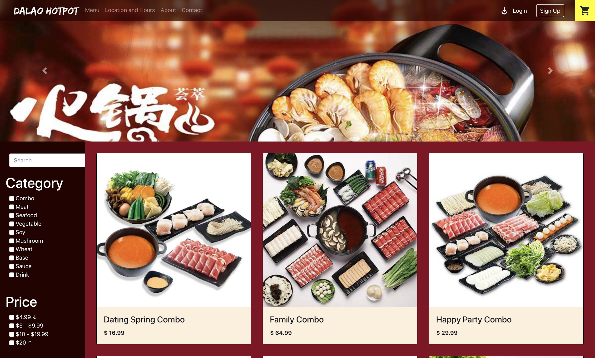
  + **Log-in & Sign-up**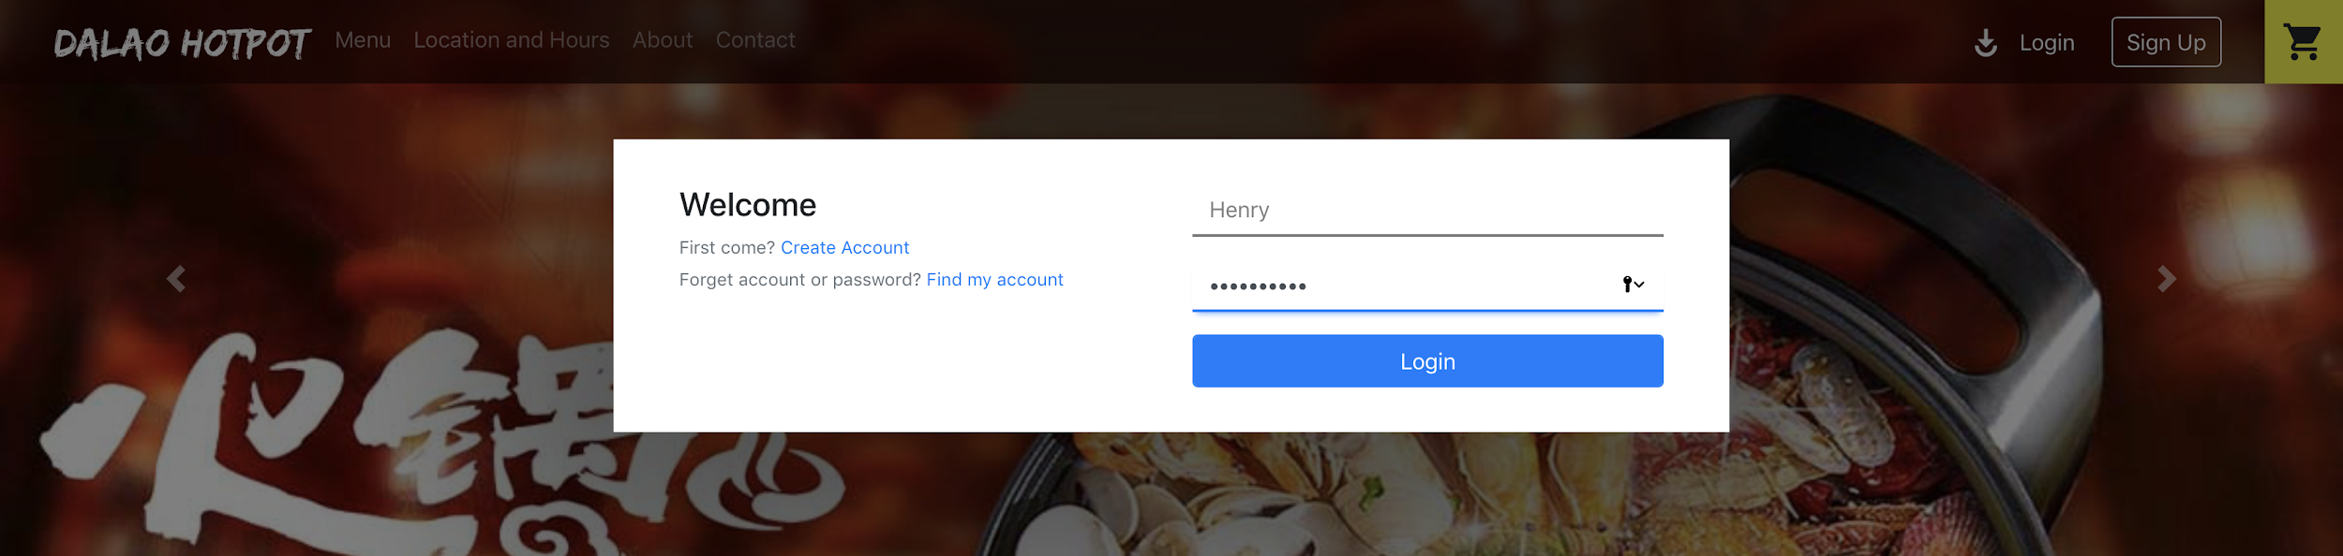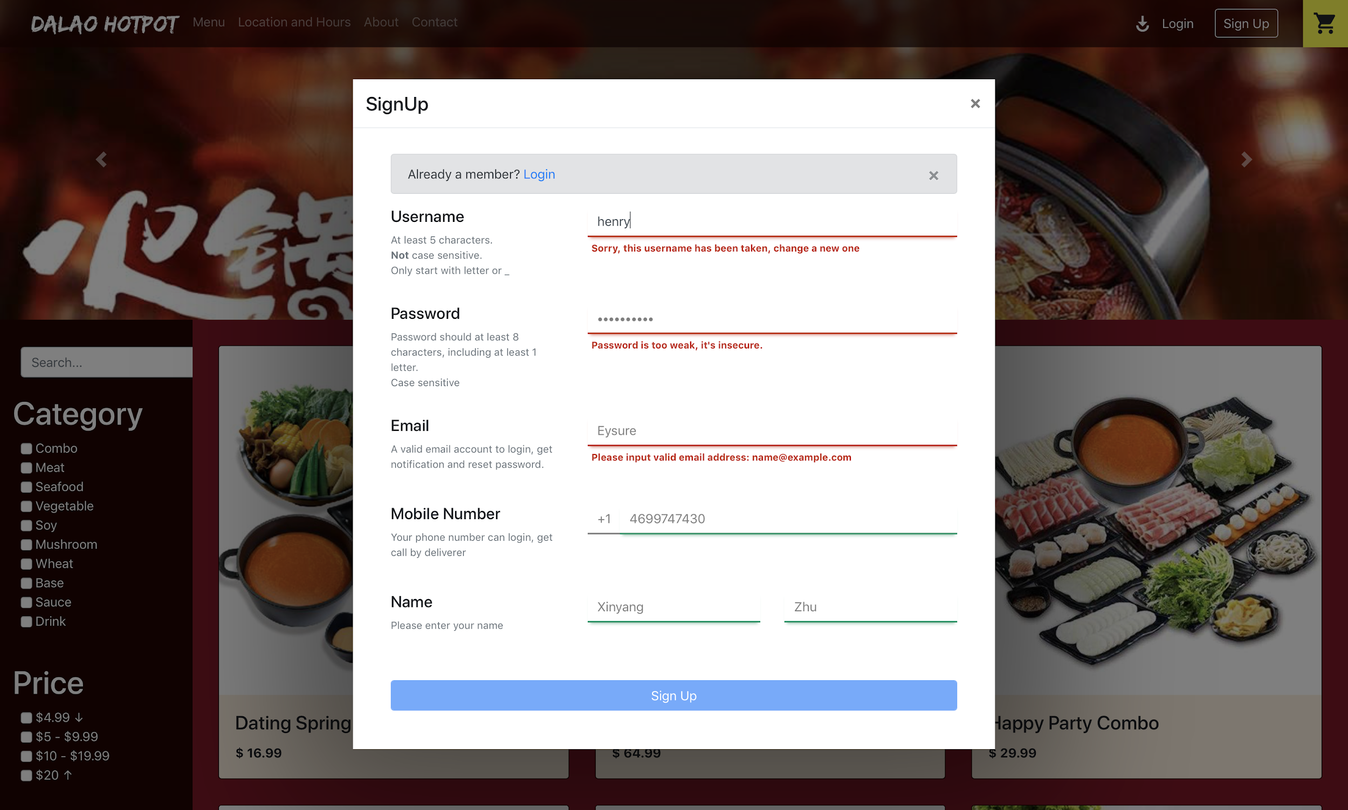
  + **Item Detail & Admin Mode**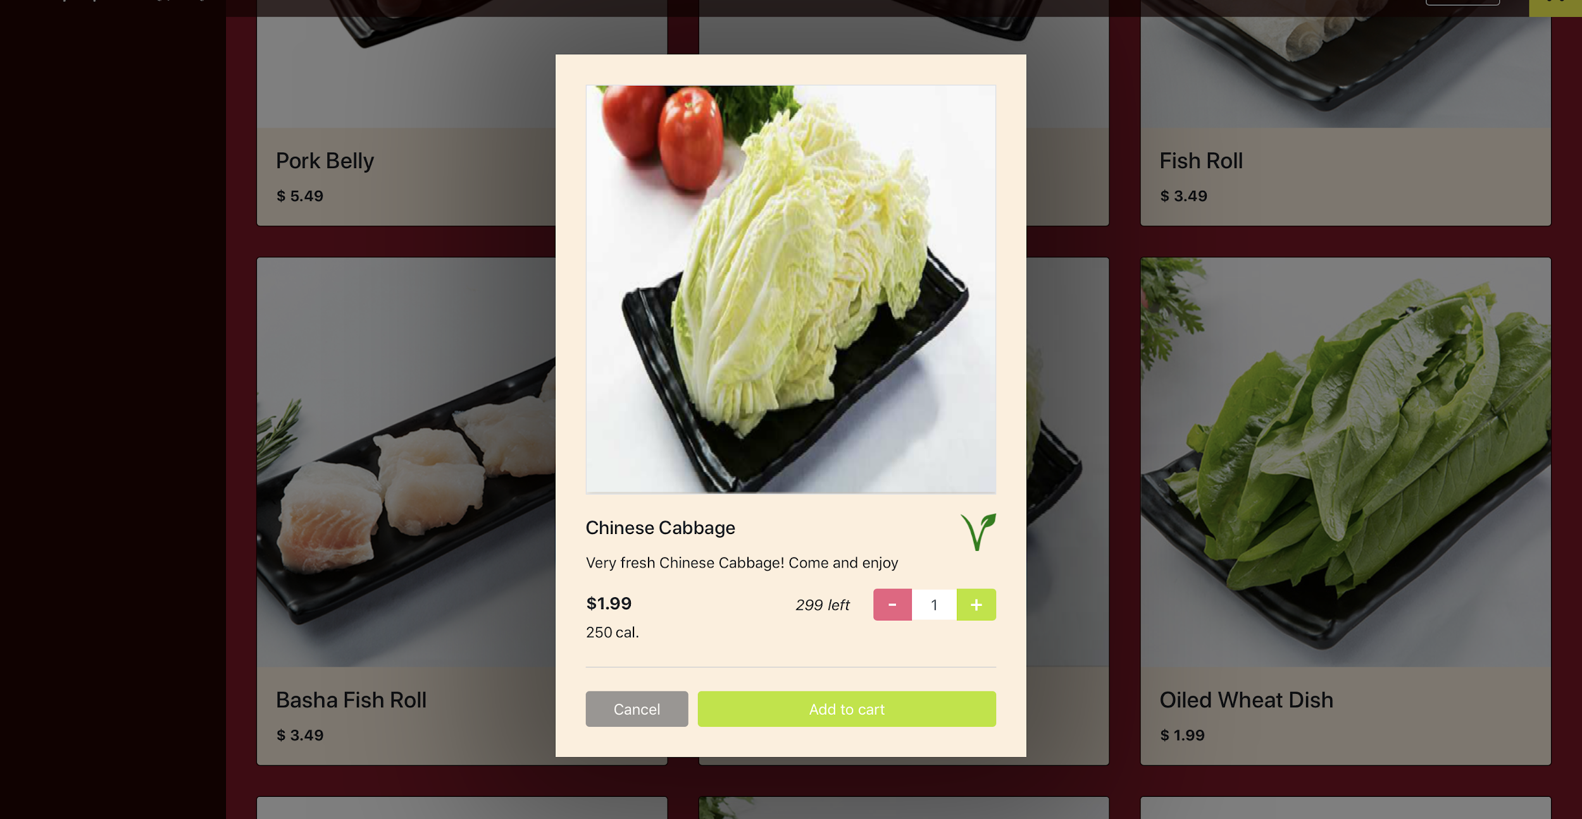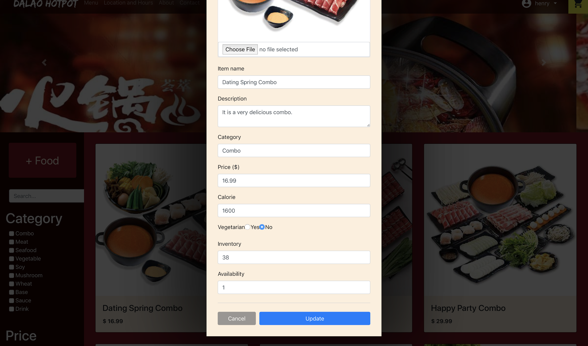
  + **Search & Filter**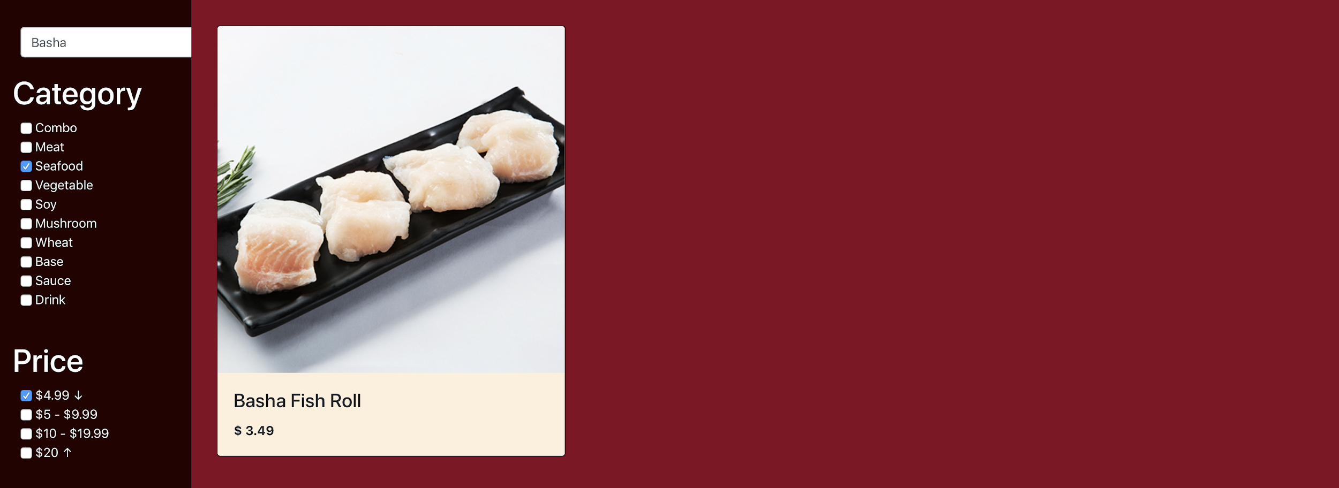
  + **Cart & Check-out**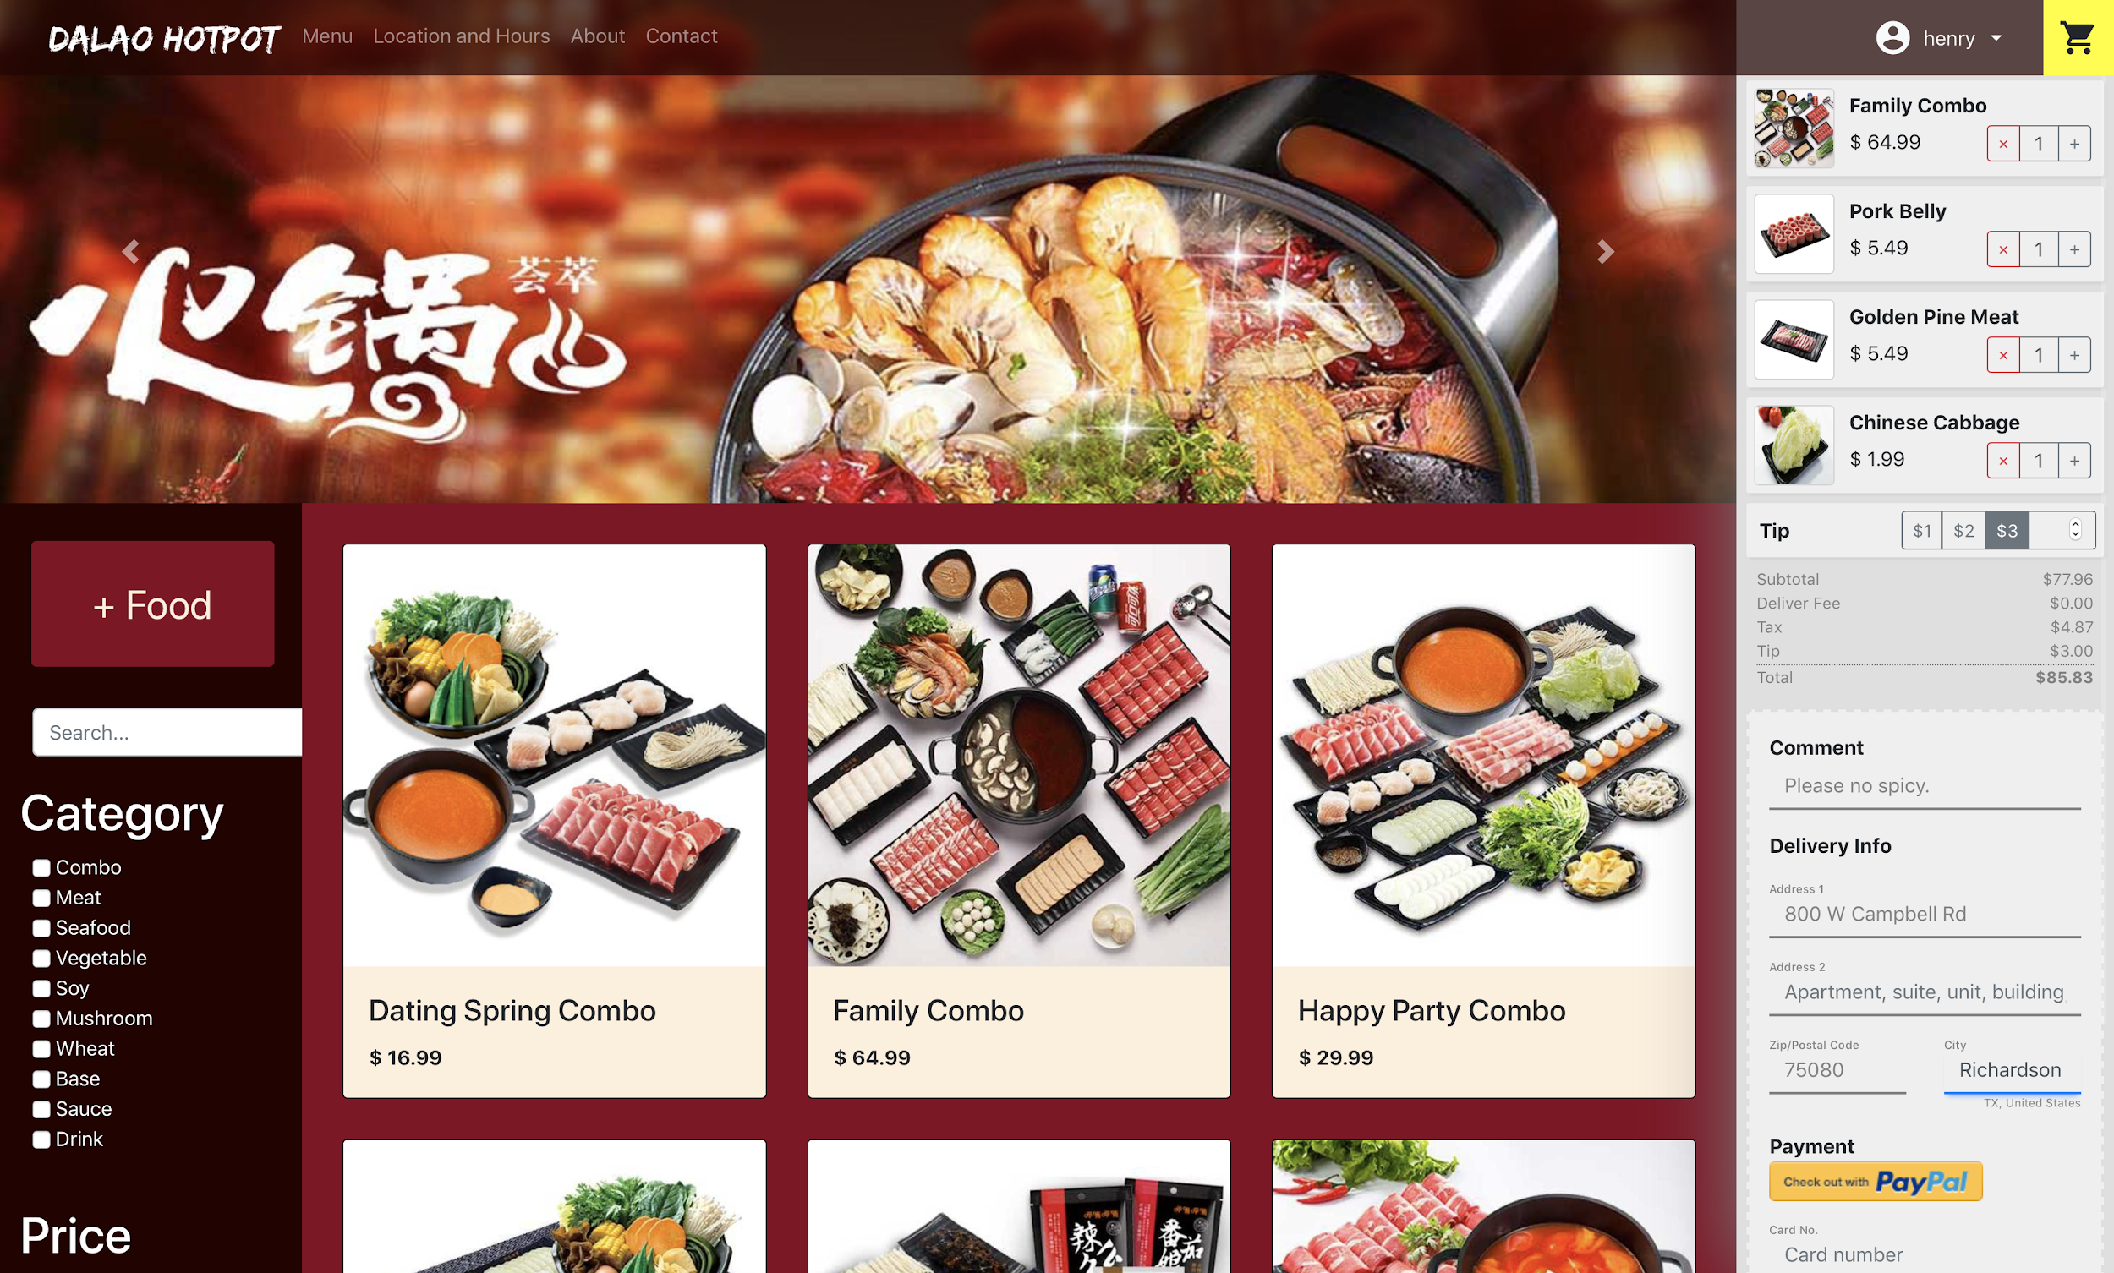
  + **Order detail**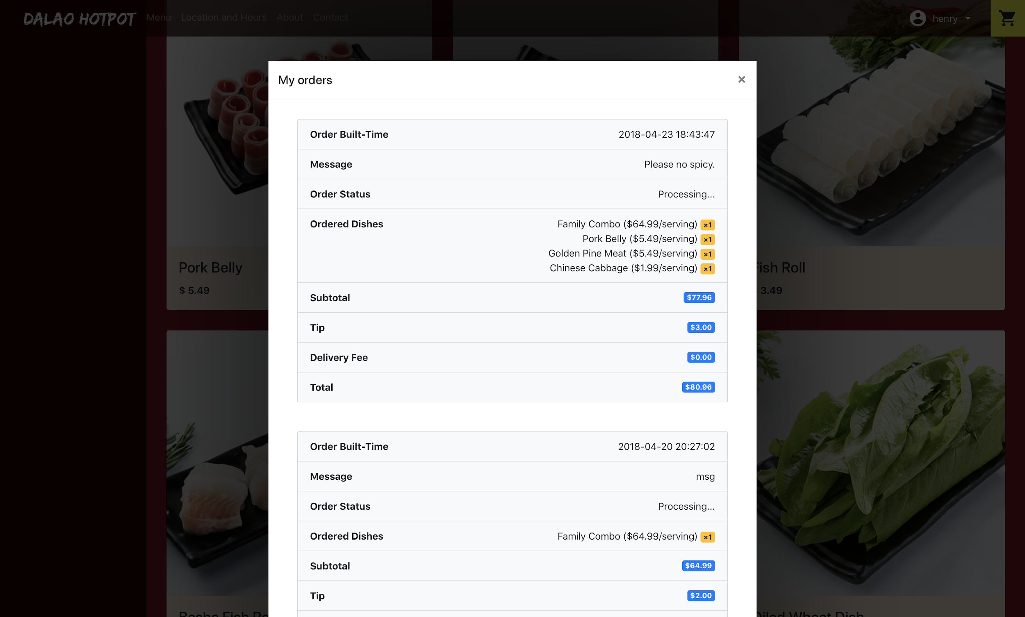

* **Team Members**

|  |  |
| --- | --- |
| **Name** | **Net-ID** |
| Ye Yao | yxy175230 |
| Hao-Lun Lo | hxl173830 |
| Xinyang Zhu | xxz170001 |

* **Work division among team members**
  + **Ye Yao**
    - Search & Filter (Front-end implement)
    - Dish List / Dish Details (UI / Front-end)
    - Add Dish (UI / Front-end / Server-side)
    - Edit Dish (UI / Front-end / Server-side)
    - Contents
  + **Hao-Lun Lo**
    - Database design / implementation / normalization
    - Homepage: Search & Filter (UI)
    - Order list (UI / Front-end / Server-side)
    - Order detail (UI / Front-end / Server-side)
  + **Xinyang Zhu**
    - Homepage: Header (UI / Front-end)
    - Log-in / Sign-up / User role (UI / Front-end / Server-side)
    - Dish (Front-end / Server-side)
    - Dish list paging (UI / Front-end)
    - Cart (UI / Front-end / Server-side)
    - Checkout (UI / Front-end / Server-side)